Code for SVM on Iris Flower Dataset

# This Python 3 environment comes with many helpful analytics libraries installed
# It is defined by the kaggle/python docker image: https://github.com/kaggle/docker-python
# For example, here's several helpful packages to load in

# Input data files are available in the "../input/" directory.
# For example, running this (by clicking run or pressing Shift+Enter) will list the files in the input directory

import os
print(os.listdir("../input"))

# Any results you write to the current directory are saved as output.

['IRIS.csv']

Iris Flower Dataset

# The following notebook uses Support Vector Machines on the famous Iris dataset.
# This dataset was introduced by the British statistician and biologist Sir Ronald Fisher
# in his 1936 paper The use of multiple measurements in taxonomic problems

# This dataset is openly available at UCI Machine Learning Repository
In [3]:
linkcode
#The iris dataset contains measurements for 150 iris flowers from three different species.

#The three classes in the Iris dataset:

# Iris-setosa (n=50)
# Iris-versicolor (n=50)
# Iris-virginica (n=50)

# The four features of the Iris dataset:

# sepal length in cm
# sepal width in cm
# petal length in cm
# petal width in cm

## Get the data

#**Use seaborn to get the iris data by using: iris = sns.load_dataset('iris') **

Importing important libraries first

import numpy as np
import pandas as pd
import matplotlib.pyplot as plt
import seaborn as sns

%matplotlib inline

In [5]:

# Import the dataset using Seaborn library

iris=pd.read_csv('../input/IRIS.csv')

In [6]:

# Checking the dataset

iris.head()

Out[6]:

 | sepal_length | sepal_width | petal_length | petal_width | species
0 | 5.1 | 3.5 | 1.4 | 0.2 | Iris-setosa
1 | 4.9 | 3.0 | 1.4 | 0.2 | Iris-setosa
2 | 4.7 | 3.2 | 1.3 | 0.2 | Iris-setosa
3 | 4.6 | 3.1 | 1.5 | 0.2 | Iris-setosa
4 | 5.0 | 3.6 | 1.4 | 0.2 | Iris-setosa

In [7]:

# Creating a pairplot to visualize the similarities and especially difference between the species

sns.pairplot(data=iris, hue='species', palette='Set2')

Out[7]:

<seaborn.axisgrid.PairGrid at 0x7fdcab664630>

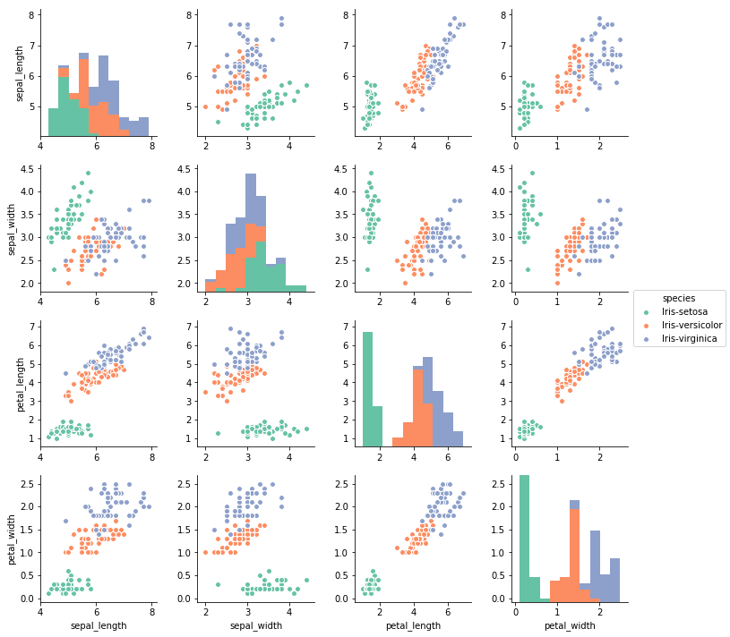

Train Test Split
In [8]:

from sklearn.model_selection import train_test_split

In [9]:

# Separating the independent variables from dependent variables

x=iris.iloc[:,:-1]
y=iris.iloc[:,4]
x_train,x_test, y_train, y_test=train_test_split(x,y,test_size=0.30)

Training and Fitting the model
In [10]:

from sklearn.svm import SVC

model=SVC()

In [11]:

model.fit(x_train, y_train)

Out[11]:

SVC(C=1.0, cache_size=200, class_weight=None, coef0=0.0,
decision_function_shape='ovr', degree=3, gamma='auto', kernel='rbf',
max_iter=-1, probability=False, random_state=None, shrinking=True,
tol=0.001, verbose=False)

Predictions from the trained model
In [12]:

pred=model.predict(x_test)

Model Evaluation
In [13]:

# Importing the classification report and confusion matrix

from sklearn.metrics import classification_report, confusion_matrix

In [14]:

print(confusion_matrix(y_test,pred))

[[17 0 0]
[ 0 16 0]
[ 0 0 12]]

In [15]:

print(classification_report(y_test, pred))

precision recall f1-score support

Iris-setosa 1.00 1.00 1.00 17
Iris-versicolor 1.00 1.00 1.00 16
Iris-virginica 1.00 1.00 1.00 12

avg / total 1.00 1.00 1.00 45

